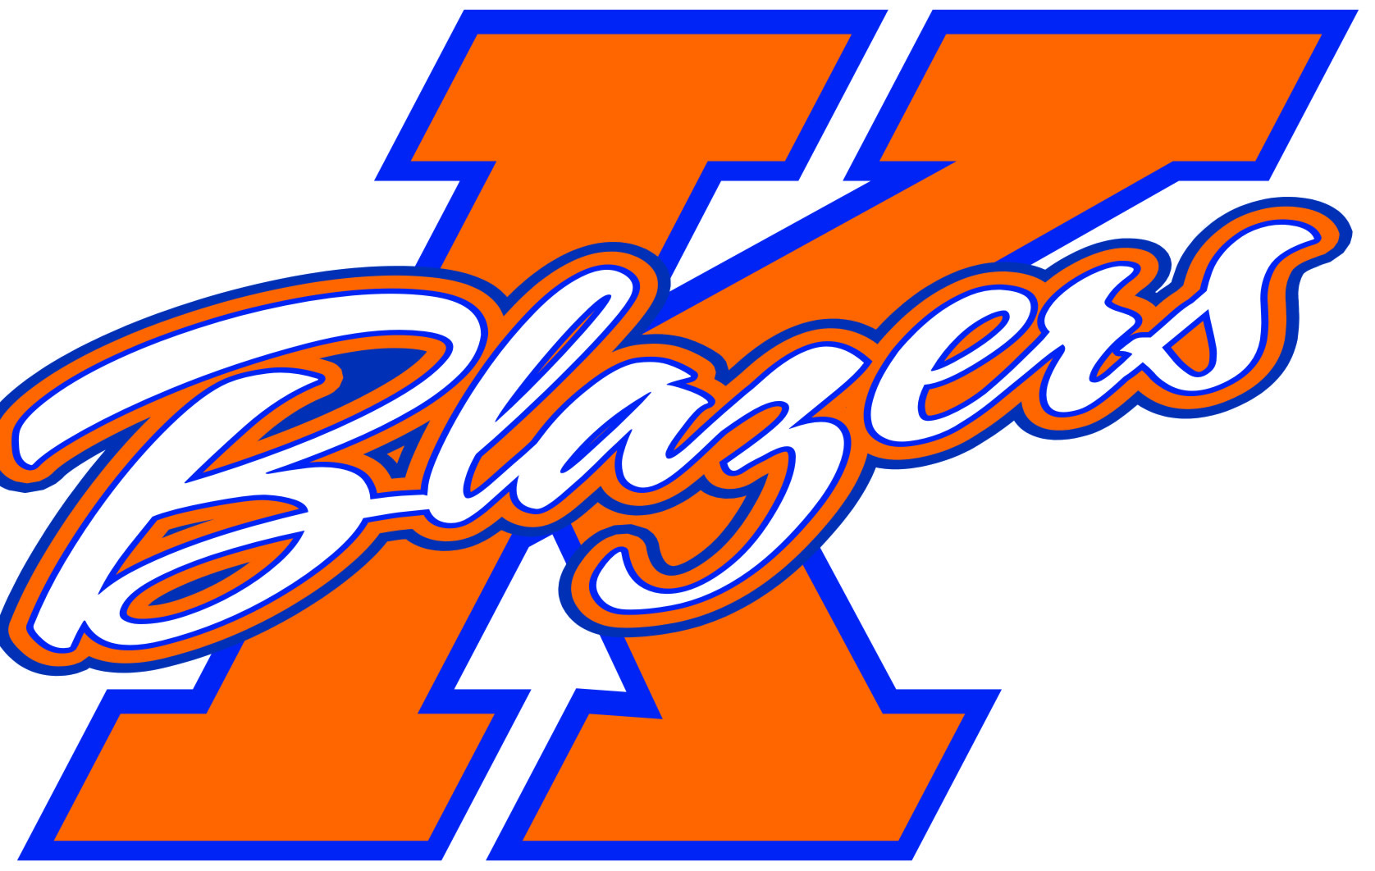2013 – 2014 Kanata Blazers
Major Peewee B

Welcome to the 2013-2014 Hockey Season! My name is Sean O’Sullivan and I am very excited to be the Head Coach of the Major Peewee B team for next season. For those of you I have not met over the past few seasons, I would like to provide you with some information about myself, my approach towards the game of hockey, and the plan for the team for the upcoming season.

The 2013-2014 season will be my 6th as a head coach with the KMHA, and third at the competitive level. I have played hockey my entire life and having the opportunity to coach some great kids over the past 6 years has been one of the most rewarding things I’ve ever done. For those of you who’s son I may have coached previously, you know that I am very passionate about the game, the process of developing player skills, bonding a strong and united team, and developing good work ethic during practices and games. It is my belief that as the coach it is my role to ensure that all of this is achieved while having a lot of fun along the way.

The primary goal for next season will be to continue to improve on the progress that was made last season. The recurring themes of respect for the opposition, hard work, and playing together as a team will once again be in place throughout the year. Practices will be run with a high level of energy and effort, with the goal of this being translated into game situations. The same effort that will be expected from the boys will also be expected from the on-ice coaches, and of course, myself.

The time commitment required from all players and parents is significant for the season. We can expect to be on the ice for 2 games and 2 practices per week (on average). In addition, there will be periodic team building events and off ice training. All players are expected to attend all team events, with exceptions being made for illness or personal reasons. That being said, despite the time requirements for hockey, it is my belief that hockey should fall after time for family and education in terms of importance. With many boys now moving on from grade school to middle or high-school, an increased level of attention to school work will be expected next season.

In addition to time, there will be a significant financial commitment. Each player will be required to pay and additional amount of approximately $1,200 for the year, which will be used to pay for additional ice, tournaments, and general team expenses.

The team will be participating in 5 tournaments over the course of the season. The schedule for the tournaments is as follows:
- Nepean Turkey Tournament – October 11th to 14th
- Syracuse Thanksgiving Tournament – November 29th to December 1st
- Bell Capital Cup – December 28th to January 1st
- Capital Winter Classic (Kanata) – January 24th to 26th
- Jay Peak, Vermont – March 7th to 9th

The dates and times for the tryouts will be posted on the KMHA website later this summer. I hope that all of the boys coming out to the tryouts will be ready to give their best effort from start to finish. The boys will be evaluated by non-parent evaluators who are not affiliated with the Peewee level in the KMHA. A parents meeting will be held prior to the tryouts where I will touch on the finer points of the tryout process and be available to answer any questions you may have about the season plan in general.

In the interim, should anyone have any questions regarding the Major Peewee B team for the 2013/2014 season, feel free to contact me at sosullivan@bentallkennedy.com .

Enjoy the rest of your summer and I look forward to seeing you at tryouts.

Sean O’Sullivan
Head Coach, Major Peewee “B” Blazers

