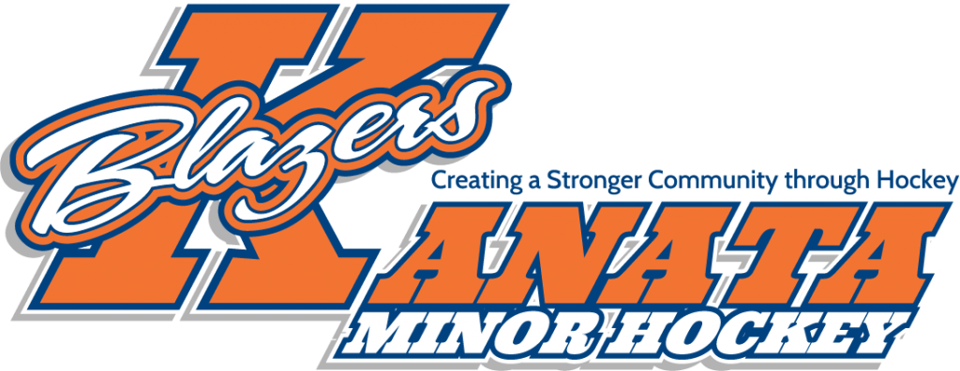

Welcome to the 2024-2025 season of the Kanata Blazers U16AA team. My name is Terry Zanatta and I am excited to be the head coach of this team. Included in this introduction letter is information regarding tryouts, my coaching philosophy, and what you can expect for the upcoming season. season. This will be my eighth year as head coach with KMHA. My philosophy in coaching is to make each player better through individual player development and teach them how to play the game of hockey through hard work and a lot of fun. I believe in trying to make every player feel like they are an important part of the team and to be successful we play as a team. I believe in teaching young players the skills of the game, introducing team concepts, and challenging them every day to be better. I try to use sport as a metaphor for life as often as possible, as it is through challenge, adversity and setbacks that we learn to deal with life’s tough times. This season players should expect to be on the ice four times a week, on average. (All players are expected to attend). There will also be periodic team events such as team building activities, parent meetings and off ice training. With competitive hockey, there comes a significant financial commitment. Families should expect to pay an additional $2500-$2900 above KMHA registration fees, which will be paid in 3 installments. (Fundraising and sponsorships may reduce these fees). This money will be used for tournaments, ice times, referees and other team expenses.

We will compete in the following tournaments:

• Mississauga Early Bird (Oct 3-5)

• Sensplex Capital Fall Classic (Oct 25-27)

• Mississauga Jets Paul Coffee (Nov 29 -Dec1)

• Capital Winter Classic (Jan 3-5)

This year’s tryout schedule has not yet been set. You should expect the dates to be posted at www.KMHA.ca in early August. I will contact each family to confirm tryout times. The team will be selected by me with detailed input from experienced, independent evaluators from both inside and outside of KMHA. The team will be looking for players with strong individual hockey skills with a heavy emphasis on player hockey IQ. NOTE: This year there will be a non parent assistant coach who will help develop this team.

Three rules that will be followed this year will be a team that works extremely hard, having players willing to learn and for everyone to fun.

In summary, I believe that hockey is a great sport and it is to be enjoyed through hard work and having fun.

In the interim, should you have any questions regarding the 2024-2025 season, please feel free to contact me at tzanatta@hotmail.com Have a great summer and I will see you at the rink.

Terry Zanatta  
Head Coach Kanata Blazers U16AA