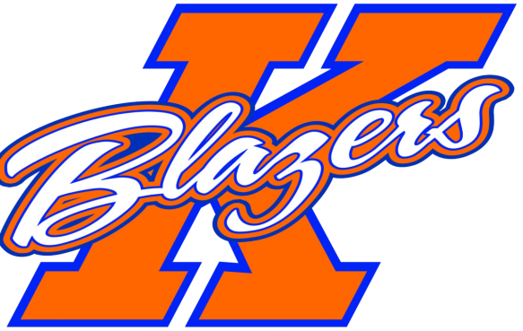
Welcome to the 2023-2024 Hockey Season! My name is Eric Beaudoin and I am honored to be coaching the U11 AA team this year. I would like to take this opportunity to introduce myself, share with you my coaching philosophy and tryout process, while also going over some details regarding the upcoming season.
I have been involved with hockey my entire life, while playing and coaching all over the world. This has given me the opportunity to learn that there are many ways to play the game and how important it is to have the ability to adapt. I am very excited to be able to share the knowledge that I have learned along the way.
I believe that hockey is a vehicle for kids to build character and confidence, which helps them prepare for life. I like to provide a positive learning environment that will challenge and push them beyond their comfort level.
Our practices will consist of skating, skill development and team tactics. The practices will be challenging and very competitive.
The three main things I expect from my players are HARD WORK, ACCOUNTABILITY, and DISCIPLINE, both on and off the ice. I believe these are the foundation to having a great team culture. Our team motto will be: “It’s hard to beat a team that never gives up”.
Tryouts will begin with skating and skills evaluations, followed by scrimmages. The evaluators have an extensive background in hockey, while not having any knowledge of last year’s team. This will be very helpful during the selection process. The tryouts will begin after Labor Day. Please check the KMHA website http://kmha.ca/ for updates to the schedule.
This year you can expect a commitment level of 4-5 days each week consisting of practices, games or off ice conditioning. On top of registration fees, team fees will be between $1700 to $2000, depending on sponsorship and team fundraising.
The plan is to attend four tournaments this season, One ‘Home’ and three ‘Away’:
- October 19-22nd Kitchener Octoberfest
- November 9-12th Kanata Shootout
- November 30th -December 3rd Sudbury Silver Stick
- January 18-21st Oakville Winter Classic
Please make sure your player shows up to tryouts ready to earn a spot. This process happens very quickly and does not give them much time to prove themselves.
There will be a quick parent meeting before the start of the first tryout to go over the tryout process. Please make sure one parent from each family is present.
I look forward to seeing you all in September. Have a great summer!

Eric Beaudoin Head Coach U11 AA Kanata Blazers

