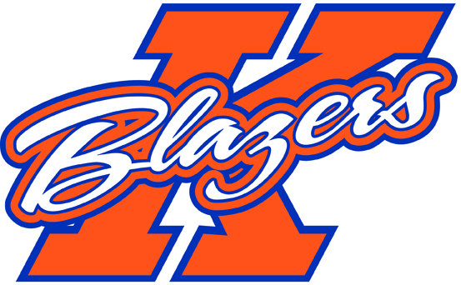

Hello Everyone,

I hope that everyone is having a good summer so far! Only 6 weeks away from the start of tryouts, so I wanted to update you with the information that I had so far.

Our tryout dates have not yet been set, but we will be starting on or shortly after Thursday August 21st, 2014. Please keep checking with the KMHA website for the tryout times. Once the dates and times are set I will be contacting each family with an email and/or phone call to confirm when their first tryout session will be. If you have not heard from me by August 15th, please get in touch with me at [bellsteven@rogers.com](mailto:bellsteven@rogers.com). It is also important that you regularly check the website before and during the tryout process as there may be changes to the times or lactations of the sessions. As I indicated in my initial letter, I will be running a physical fitness test during the tryout process (time and location tbd). This session will consist of:

1. 3 km timed run
2. Push ups to failure
3. Plank to failure
4. Shuttle run

The fitness testing will be used as an evaluation component for the selection of the team, so please ensure that your player has prepared themselves physically over the summer.

There has been a change to one of the dates for our tournament schedule. The dates we have confirmed are as follows:

* September 12 – 14, 2014, Garden City Early Bird (Niagara Falls, ON)
* November 7 – 9, 2014, Kingston Canadiens Tournament (Kingston)
* November28-30, 2014, Silver Stick (Sudbury)
* December 29 – January 2, 2015, Bell Capital Cup (Ottawa)
* January23-25, 2015, Capital Winter Classic (Kanata)

Please keep checking the website for any further updates. Enyoy the rest of your summer and I look forward to seeing you in late August for tryouts.

Steve Bell

Head Coach

Major Peewee AA