**2014 – 2015 Kanata Blazers**

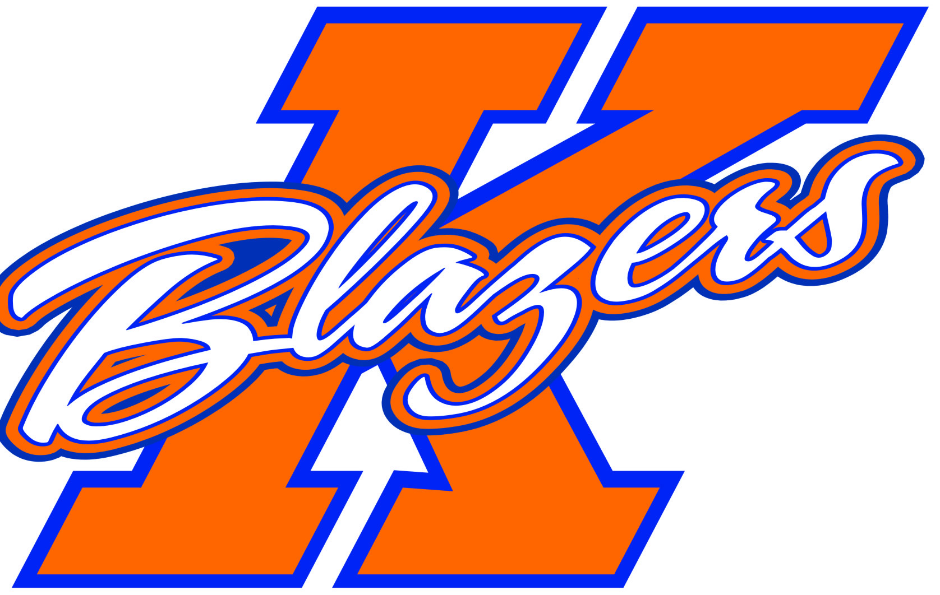

**Minor Atom Rep B**

Welcome to the 2014-2015 Hockey Season. My name is Jordan Goodfellow and I am very excited to be the Head Coach of the Minor Atom B team for next season. For those of you I have not met over the past few seasons, I would like to provide you with some information about myself, my approach towards the game of hockey, and the plan for the team for the upcoming season.

The 2014-2015 season will be my 2nd as a head coach with the KMHA I am part Owner and Full Time Managing Partner at a Hockey Training Facility in Stittsville . I played AA Hockey my entire Playing career as a goalie. The Year I was supposed to play junior I broke all the knuckles in my catching hand playing football in gym class that ended my career as a goalie. From there I have always been passionate about the game. Last year I decided to coach in my first year as coach I won the Coach of the year as voted on by my fellow coaches for the extra help and Time I put in with other teams. I am a very committed to everything that I will do and I expect the same out of my players.

The time commitment required from all players and parents is significant for the season. We can expect to be on the ice for at least 1 games and 2 practices per week (on average). I expect every player In addition to attend all periodic team building events and off ice training. All players are expected to attend all team events, with exceptions being made for illness or personal reasons. That being said, despite the time requirements for hockey, it is my belief that hockey should fall after time for family and education in terms of importance.

In addition to time, there will be a significant financial commitment. Each player will be required to pay and additional amount for the year, which will be used to pay for additional ice, tournaments, and general team expenses.

The team will be participating in at least 4 tournaments that are already confirmed over the course of the season and possibly 2 more. The schedule for the tournaments is as follows:

* Belleville Pre Season Tilt – September 26th – 28th
* Capital Volunteer Cup – October 24th to 26th
* Cobourg Silver Stick – November 28th to 30th
* Cell Capital Cup – December 28th – January 1st
* One additional local tournament – TBD
* International Silver Stick _ TBD

The dates and times for the tryouts will be posted on the KMHA website later this summer. I hope that all of the boys coming out to the tryouts will be ready to give their best effort from start to finish. Non-parent evaluators who are not affiliated with the Atom level in the KMHA will evaluate the boys. A parents meeting will be held prior to the tryouts where I will touch on the finer points of the tryout process and be available to answer any questions you may have about the season plan in general.

In the interim, should anyone have any questions regarding the Minor Atom B team for the 2014/2015 season, feel free to contact me at Jordan@613hockey.com

Jordan Goodfellow

Head Coach, Minor Atom “B” Blazers