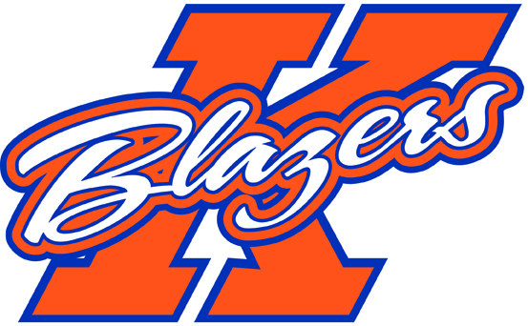

Welcome to the 2014-2015 hockey season. My name is Steve Bell and I will be the coach of the Kanata Blazers Major Peewee AA team this coming year. I am very happy and excited to take on this role! I want to take an opportunity to introduce myself, my coaching philosophy, some of the expectations of the season and a bit about my tryout process.

I have been a coach in the KMHA for the past 10 seasons, taking on roles as both head and assistant coach at the competitive and house league levels. Beyond coaching hockey, I have coached a variety of sports at both the community and high school levels for the past 25 years. My approach to coaching is quite simple: I am looking for players to have fun, commit to their team, work hard, and play a disciplined game that helps to achieve team goals. I also believe that all are individuals and should be allowed to be creative and discover what strengths they can bring to their team, both on and off the ice. I will focus on player skill development, as well as team tactics and systems that allow the players to progress and develop as both individuals and members of their team. My goal is for each of the players and the team to continue their improvement and development over the entire season.

I have had the opportunity to work with the 2002’s for the past 5 years. This is a very skilled group of hockey players who are seen as a force in their age group across the city. This group has benefitted from strong coaching over the past several years, a tradition that I intend to continue. My plan for the season is to have the players continue to progress in their hockey skills, knowledge, understanding of the game and critical thinking abilities. This will be accomplished through the execution of a seasonal plan that will be delivered through high tempo, challenging practices, both on and off the ice.

I will focus this season on the development of the complete athlete. This means that there will be both on and off ice components to the program, with a focus on hockey skill development, personal fitness and healthy lifestyle choices. The players will be involved in team activities and have individual training expectations placed on them to meet the goals that will be set out. Sports are a great venue to teach so many life skills, and a passionate 12 year old hockey player is a great audience.

As with all competitive sports, there is a high level of commitment that is required from the players and their families. Major Peewee AA players can expect to be at the rink 4-5 times per week. This will normally include 2 games and 2-3 practices. In order for a team to progress as a cohesive unit, it must work as a team, so it will be expected that players attend all team functions. Competitive hockey also brings with it a financial cost. Players’ families can expect to pay between $2000 and $2300 for team fees this season, as well as the cost associated with 3 out of town tournaments.

The team will attend 5 tournaments this season. These tournaments are as follow:

* September 12 – 14, 2014, Garden City Early Bird (Niagara Falls, ON)
* November 7 – 9, 2014, Kingston Canadiens Tournament (Kingston)
* December 4 – 7, 2014, Silver Stick (Sudbury)
* December 29 – January 2, 2015, Bell Capital Cup (Ottawa)
* January 23-25, 2015, Capital Winter Classic (Kanata)

This year’s tryout schedule has not been set. The dates are normally posted on the KMHA website in late July or early August so please check the site regularly to confirm when the tryouts will be held. For the tryouts, I will be using independent evaluators to assist me in selecting the team who will be evaluating a combination of skills, intra squad scrimmages, exhibition games, fitness testing (cardio endurance, core and upper body strength, beep test) and player interviews, to make a final determination of the 17 players that will be this year’s Major Peewee AA team. I am looking to build a team of 17 players who work hard and compete on the ice, are disciplined and are committed to team play.

Please ensure that your child takes the Summer to prepare themselves to come and compete at tryouts. The tryout sessions that we have should be an opportunity for the players to showcase the hard work that has been put in over the Summer months. The Summer should be used as an opportunity for some individual skill development (i.e. shooting, skating, stickhandling), fitness preparation and cross training activities (playing another sport, for example). Players are expected to come to the tryouts prepared to compete for a spot on this team.

Prior to the tryouts, I will post more information about the process. I will also be having a parent meeting before the tryouts begin to reiterate this any more information about the tryout process as well as parent expectations.

I look forward to seeing you all in August, have a great summer!

Steve Bell

Head Coach

Major Peewee AA

Kanata Blazers