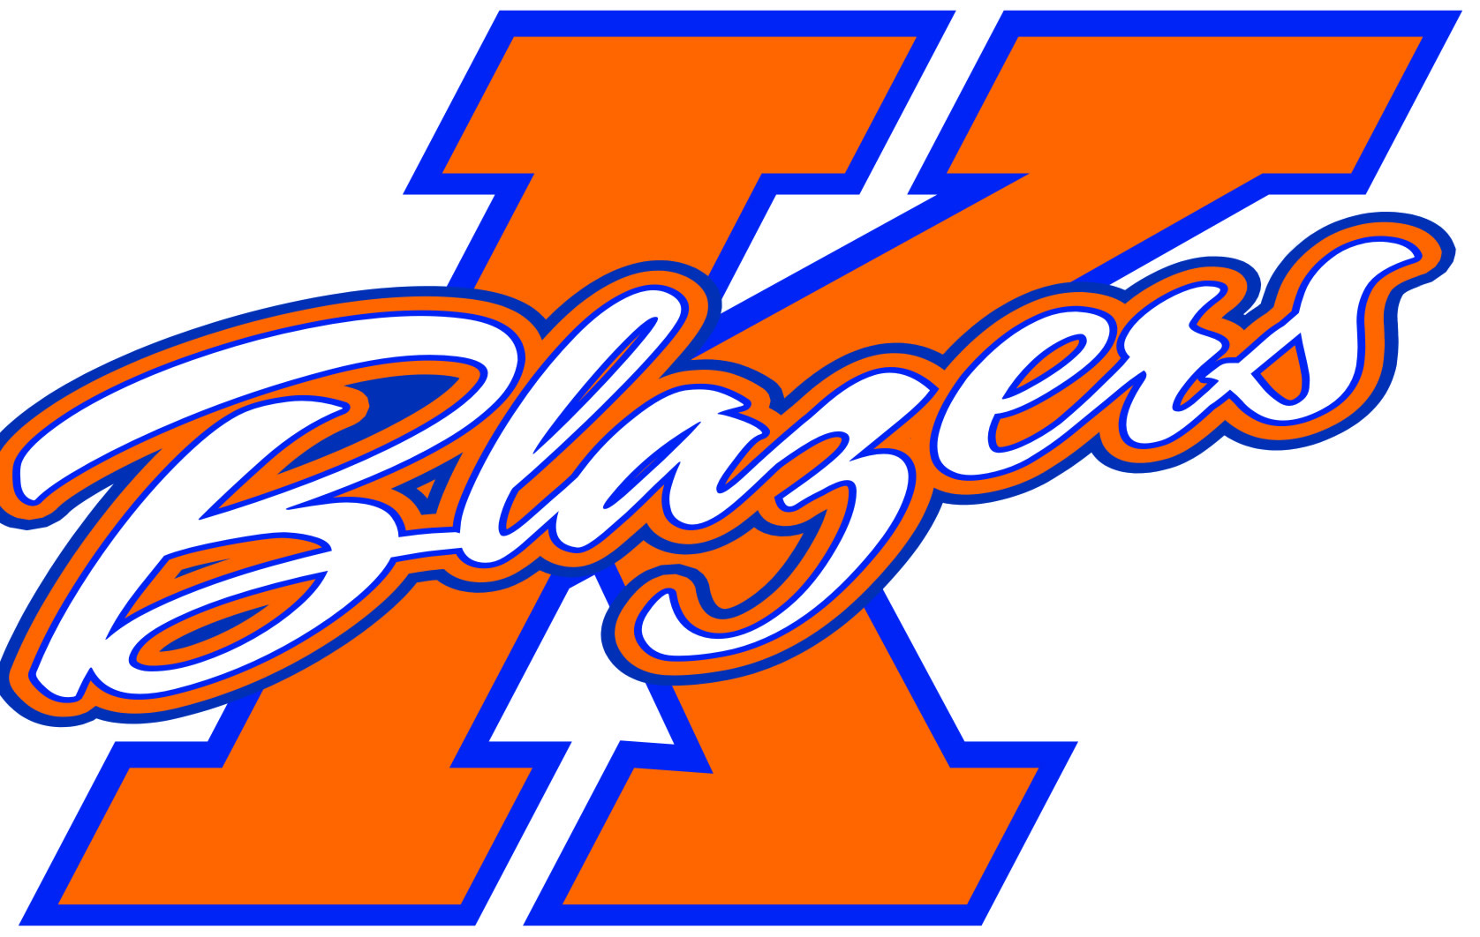2014 – 2015 Kanata Blazers
Minor Bantam Rep B

Welcome to the 2014-2015 Hockey Season. My name is Sean O’Sullivan and I am very excited to be the Head Coach of the Minor Bantam B team for next season. For those of you I have not met over the past few seasons, I would like to provide you with some information about myself, my approach towards the game of hockey, and the plan for the team for the upcoming season.

The 2014-2015 season will be my 7th as a head coach with the KMHA, and fourth at the Rep B level for the 2001 age group. Helping run the team for next season will be Sylvain Richer, who is entering his 3rd season with the 2001 Rep B players. Both Sylvain and I have a similar outlook on both coaching and how the game should be played. Our ultimate goal for the season is obviously for the boys to have success on the ice. However, just as important (and how we evaluate the true success of a season) is to continue to develop the players hockey skills, to establish an expectation that a solid effort will be given by all players and coaches in all games and practices, and to ensure that all players are good teammates first and foremost. It is our belief that as their coaches it is our role to ensure that all of this is achieved while having a lot of fun along the way.

The time commitment required from all players and parents is significant for the season. We can expect to be on the ice for 2 games and 2 practices per week (on average). In addition, there will be periodic team building events and off ice training. All players are expected to attend all team events, with exceptions being made for illness or personal reasons. That being said, despite the time requirements for hockey, it is my belief that hockey should fall after time for family and education in terms of importance. With the boys now getting close to the high-school age, an increased level of attention to school work will be expected next season.

In addition to time, there will be a significant financial commitment. Each player will be required to pay and additional amount of approximately $1,200 for the year, which will be used to pay for additional ice, tournaments, and general team expenses. Please ensure that your son has completed a body checking clinic put on by the KMHA prior to the first tryout. They will not be able to participate in tryouts unless this is done. Information on this clinic will be sent out later in the summer.

The team will be participating in 5 tournaments over the course of the season. The schedule for the tournaments is as follows:
- Nepean Turkey Tournament – October 10th to 13th
- Belleville Shriners Tournament – October 24th to 26th
- Syracuse Thanksgiving Tournament – November 28th to 30th
- Capital Winter Classic (Kanata) – January 9th to 11th
- One additional local tournament - TBD

The dates and times for the tryouts will be posted on the KMHA website later this summer. I hope that all of the boys coming out to the tryouts will be ready to give their best effort from start to finish. The boys will be evaluated by non-parent evaluators who are not affiliated with the Bantam level in the KMHA. A parents meeting will be held prior to the tryouts where I will touch on the finer points of the tryout process and be available to answer any questions you may have about the season plan in general.

In the interim, should anyone have any questions regarding the Minor Bantam B team for the 2014/2015 season, feel free to contact me at sosullivan@bentallkennedy.com .

Enjoy the rest of your summer and I look forward to seeing you at tryouts.

Sean O’Sullivan
Head Coach, Minor Bantam “B” Blazers

