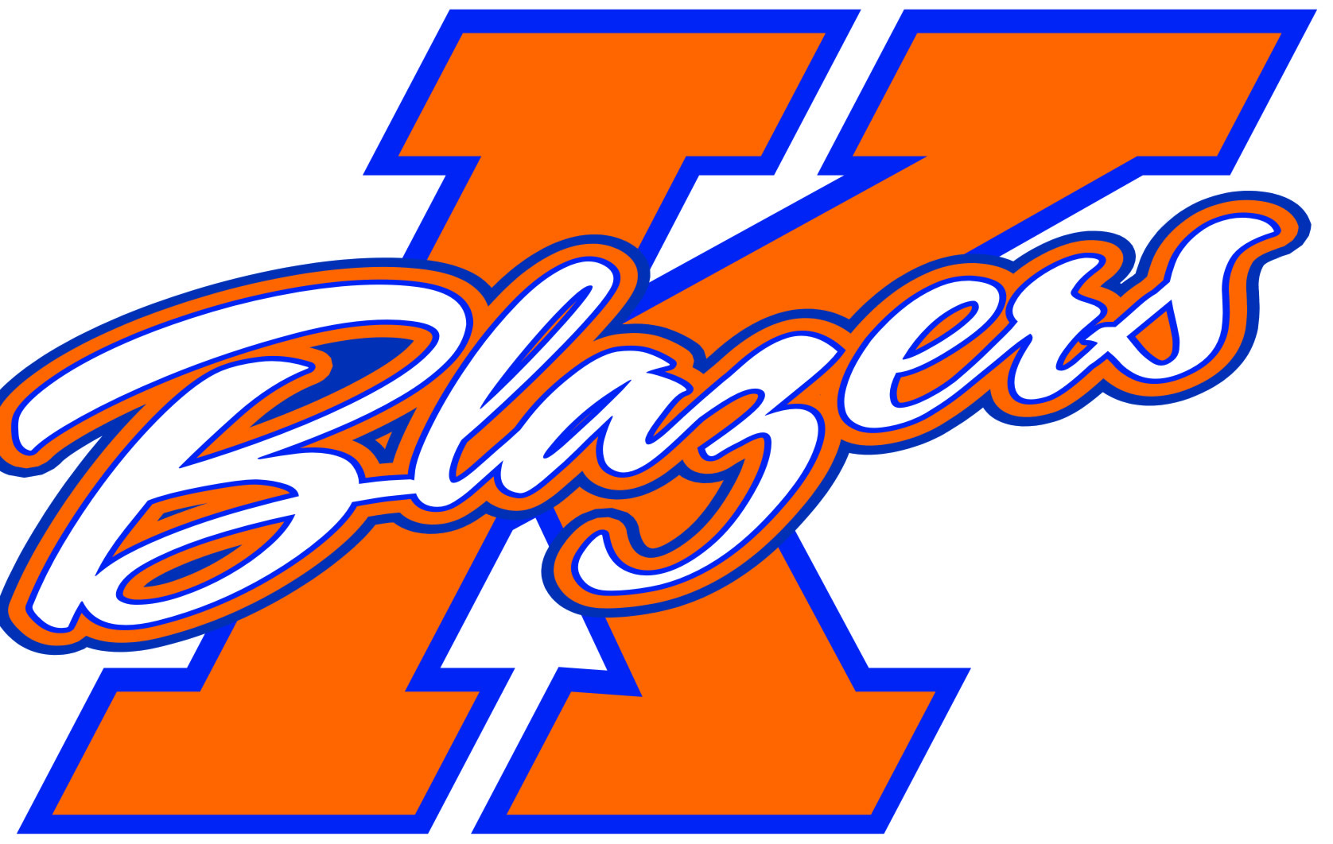Kanata Blazers Major Bantam B

Welcome to the 2013 - 2014 Major Bantam REP B Hockey Team.
My name is Geoff Ley and I am your non-parent Head Coach.
Team credo:
"Invincibility lies in the defense; the possibility of victory in the attack."
What I believe in:
1) strong defensive hockey, team first mentality
2) play loose, 100% confidence, take chances, aggressive, make mistakes
3) conditioning, DISCIPLINE, mental toughness
4) create a positive atmosphere, fair play all situations
5) 100% effort at all times, have fun, be energized
Our tournament schedule:
Jay Peak Vermont, Fall Challenge Nov. 1 - 3
Syracuse NY, USA Thanksgiving Nov. 29 - Dec. 1
Capital Winter Classic (KMHA) Jan. 10 - 12
Rochester NY, Presidential Power Play Feb. 15 - 17
Under consideration:
NCAA experience (Clarkson) date TBD
Watertown NY exhibition games date TBD
I hope to see you all in a few short months.
Come prepared with confidence and courage.
Have a safe and enjoyable summer!
Coach Geoff
geoffley@rogers.com

