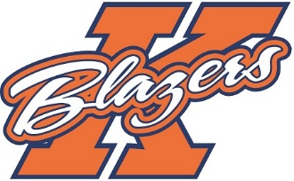

Welcome all players trying out for the 2018/2019 Kanata Blazers Major Bantam AA team. My name is Mario Martel and I am the Head Coach for this upcoming season. I am very honoured and looking forward to working with the team again and making this a positive and successful experience for both players and parents. I would to take the opportunity to introduce myself to those who do not know me and provide a brief overview of some key items for this upcoming season.
I have been involved with KMHA for the past 6 years in various roles including head coach, assistant coach, trainer, conditioning coach and most recently Head Coach of the 2017/18 Kanata Blazers Minor Bantam AA.
My coaching philosophy is all about “THE PROCESS”. Training, practice and mental preparation. This year I plan to share my enthusiasm of “THE PROCESS “through high pace practices and off ice training, preparing player’s both physically and mentally for the game. This year’s coaching program will focus on: work ethic, commitment, team play and individual skill development, both on and off the ice. To be a member of the team, players will need to demonstrate they understand these principles. In addition to the benefits of hard work, I will also place an emphasis on discipline, both on and off the ice. Players will be expected to commit to the team, attending all practices, games and team events throughout the season.

This year the team will be participating in 4 tournaments. (3 away and 1 home). Applications have been submitted to participate in the following tournaments however the list may change based on acceptance:
September 6-9, 2018 4th Annual Break the Ice Tournament – Ajax
November 1-4, 2018 – Pickering AA tournament
November 30-December 2, 2018 – Paul Coffee Invitational - Mississauga
January 4-6, 2019 15th Annual Capital Winter Classic (home)

The December Christmas break will be a blackout to allow for time to spend with family and for players to recharge. Depending on our league schedule, you can expect our team to completely shut down with no events scheduled between December 24 and January 1.

As part of the team concept, it is expected that during tryouts and throughout the year Kanata team dress code will be in effect: All players are to wear their Blazer team gear during team events and dress clothing for games.
• Good pants (no jeans or coloured jeans), shirt, tie and Blazers jacket for all exhibition games and regular season games
- Kanata Blazers work out attire for all team events – practice, dryland etc.
• Dress pants, shirt, tie and Blazers jacket for all games for coaches,
- Blazers track suit for trainers,

As with any competitive sport, hockey takes commitment (both time and financially). Players can expect to be training 4-5 times per week. This will include both on and off ice sessions.

In terms of team financials, families should anticipate team fees of approximately $2,000 per player in addition to the KHMA registration and try out fees. Team fees will be paid over 4 instalments with full payment completed in December.

The team will be selected by experienced independent hockey personnel from the community and our coaching staff.

I am looking for players with strong work ethic, a demonstrated understanding of the concept of team before individual play, fundamental individual skills and tactics and a good hockey sense. Players should be in good physical and mental condition and are expected to come to tryouts prepared and ready to compete for a spot on the team.

I hope you have a great summer and we will see you in August for tryouts. Looking forward to a great season!

Sincerely,

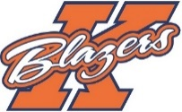

Mario Martel
Kanata Blazers
Head Coach
Major Bantam AA

