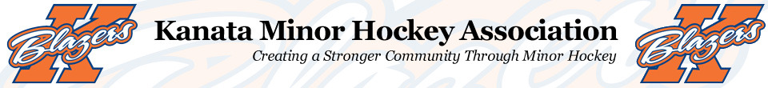

My name is Nathan Barwell and I am extremely excited to welcome you to the 2018-2019 Minor Atom Rep B Team. Below you will find a little information on me, my coaching philosophy and what to expect from the upcoming season.
I have played hockey since I was 4 years old and it is an absolute passion of mine. This is my 5th year involved with KMHA, and is my 4th as Head Coach. Being able to pass along things I have learned and share in the successes of the players has been very rewarding and I look forward to another great experience this season.
The overall goals for this season are very simple. The most important things to me are that the players have fun and get better each and every time we are together. I plan to work towards a strong skating team that will be challenged to play the game fast. As this age is still very much a developmental age group, you can expect that much of the focus, especially early in the year, will be to develop each player’s individual skating skills. There will also be continual focus will be on developing each player’s individual technical skills including puck control, passing and shooting. It is my belief that players with strong individual skills are the foundation of a successful team. Additionally, team work and team play will be a highly emphasized factor for the group and each child will be expected to play and behave as a TEAM member.
Over the course of the tryout process, I will be looking for players who are hardworking, competitive, good listeners and have a willingness to learn to get better. Tryouts will consist of both a skills & drills session and competitive scrimmages/exhibition games. Players are being evaluated as soon as they check into the arena. Evaluations will be done with third party non-parent evaluators, who will be looking at individual skill sets (skating/passing/shooting/puck skills). Equally important, they will be evaluating the players compete levels, game awareness and TEAM play. Dates and times are not currently available for tryouts, but will be posted on the KMHA website (www.kmha.ca) later this summer, and I will be contacting each family to ensure they have all the information.
This season, families should expect to commit to 4-5 team events per week. Practices will be planned to focus on skating development, skill development and team play. In addition, there will also be periodic team events that will allow us to continue team building in different settings. Players are expected (to the best of the families abilities) to attend all sessions.
With all competitive sports, there is a significant financial commitment expected. Families should expect a team fee of approx. $1300 above KMHA registration fees. We will look for sponsorship and fundraising to assist with these costs. These fees will be paid in 3 installments. These fees will be used for ice time, officials, tournaments and other team activities/requirements.

The team will also participate in 5 tournaments this year, 2 of which will be out of town. Proposed tournament list is as follows:
- Capital Blues Hockey Fest – Richcraft Sensplex – Sept 28-30
- Bradford Blue & Gold – Bradford, On – Oct 12-14
- Osgoode Richmond Romans Fall Classic – Richmond, On – Nov 8-11
- Oshawa Hockey Fest – Oshawa, On – Dec 7-9
- Capital Winter Classic – Bell Sensplex – Jan 18-20
  - Note: Tournament schedule subject to change based on acceptance
I am extremely excited for the upcoming season. Again, with the goals being to have fun, and to get better, there is no limit to how the group will grow. I will be reaching out to confirm tryout times once they are available. In the interim, should you have any questions, please feel free to contact me at nathanbarwell@yahoo.ca Enjoy your summer and I look forward to seeing everyone at the rink!
Regards,

Nathan Barwell
Head Coach
Kanata Blazers Minor Atom B

