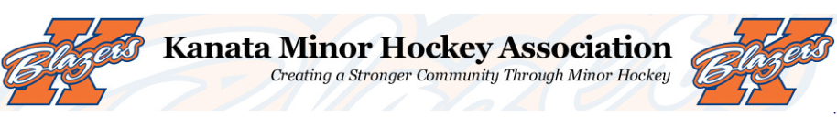

Welcome to the 2018-19 hockey season!
My name is Ryan Kealey and I am honored and excited to be taking on the role of head coach for the Minor Atom rep A team this year. I am very passionate about the game of hockey and believe I can continue to pass along what I’ve learned from my 30+ years of hockey experience to our young Kanata players. I have been a part of the Kanata Minor Hockey Association for the past 4 years and most recently as head coach of the Major Novice Rep A team.
My coaching philosophy will be based on developing fundamental skills and the following three rules:
1. Work hard
2. Have fun
3. Learn

I also believe when young athletes are working hard, focused and listening they will become better hockey players. I also want to create a fun atmosphere and I’ll work to achieve this by developing upbeat and strategic practice plans that work on the developing skills and tactics of players at the Atom level. Players at this age need to continue to develop the fundamentals while having the message positively reinforced.
For evaluations/try outs I will be looking for strong skaters, hard workers, competitiveness, good listeners, strong positional play and determination. During the tryouts players will be evaluated on their performance including skating and individual skills during an on ice session. They will also be evaluated on their game play, effort level, positional play and other fundamental skills during inter-squad and/or exhibition games. Evaluations of players will be completed by non-parent independent evaluators to ensure a fair and transparent process. The dates and times for tryouts will be posted on the KMHA website (http://kmha.ca/) later this summer. I encourage all who tryout to play with intensity and an abundance of energy!
This upcoming season’s time and financial commitment will be significant. You can expect, on average 3-5 sessions per week throughout the entire season. This will consist of 1-2 games as well as 2-3 practices. Our practices will focus on age appropriate drills for the Atom level players and will be upbeat, fast and fun! I understand that family obligations will come into play throughout the season but please know that players are expected to attend all team events. As mentioned above there will be a significant financial commitment as well. Each player selected will be required to pay a team fee of approximately $1,500.00. This is in addition to the KMHA registration fee and try-out fee. Sponsorships are currently being sought to help alleviate the costs as well as fundraising opportunities throughout the year.

The tournament schedule for the upcoming season will include the following:
- Pat Larock Memorial Tournament (Peterborough ON) – Sept 6 – 9, 2018 **
- Capital Fall Classic (Local) – Oct 19 – 21, 2018
- International Silver Stick (Stratford ON) – November 2 – 4, 2018
- Bell Capital Cup (Local) – December 28 – 30, 2018
- 5th tournament TBD (Local) – January/February 2019
** Subject to change
Should anyone have any questions regarding the Major Atom A rep team for the 2018-19 season I can be contacted at ryan.kealey27@gmail.com . Have a great spring and summer and I’ll see you in August.

Ryan Kealey
Head Coach
Kanata Blazers Minor Atom A

